EZVIZ 2020 Prime Day Deals: Up to 40% off on Your Most Desired Security Cameras

LA, Oct. 13, 2020-- EZVIZ, the award-wining smart home security brand, is offering the best annual sales during Amazon Prime Day 2020. Beginning today to Oct. 18, EZVIZ offers up to 40% off their most desired products for families and business owners who plan to upgrade the protection system. Best deals range from the revolutionary C3X color night vision camera which has been selected by numerous tech publications as the Best Outdoor Security Camera for 2020, to the battery-operated 100% wireless C3A camera family.

EZVIZ is running promotions across all Amazon sites:
US - https://amzn.to/3dgDUV5
UK - https://amzn.to/34Ko29B
Spain - https://amzn.to/34I3bUt
Germany - https://amzn.to/34MTUKC
France - https://amzn.to/3luLMW7
Italy - https://amzn.to/3dgEPF1
Australia - https://amzn.to/36eQ2V9

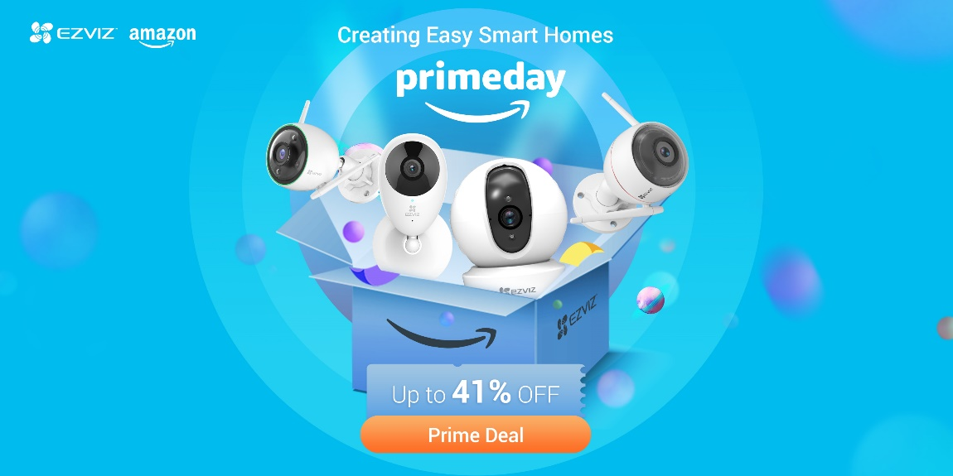

EZVIZ C3X dual-lens color night vision camera with built-in AI
Up to 36% OFF
- Les Numeriques Editor’s Pick
- Tech Aeris Editor’s Choice 2020
- Excellent color night vision
- Person and vehicle detection
- Line-crossing detection
- Customizable detection zones and warning audio
- Weather-proof design
- Two-way talk

EZVIZ C3N outdoor cam with color night vision
Up to 30% OFF
- Real Homes Best Security Camera to protect your house
- Smart Spotlight Color Night Vision
- Intelligent Person Detection
- Customizable Detection Zones
- IP67 Waterproof

EZVIZ C3A Battery Camera Duo/Triple
Up to 40% OFF
- 100% Wire-free
- Long-lasting battery life for months of protection
- Two-way audio
- PIR motion detection
- Real-time notifications

EZVIZ C1C / C1 mini. One product in two shapes.
Up to 30% OFF
- T3: best cheap security camera 2020
- 1080p video with 40ft super night vision
- Customizable detection zones
- Two-way talk
- Magnetic base

EZVIZ C6CN Pan Tilt Camera
Up to 40% OFF
- 1080p video and 360° coverage
- Night vision up to 33ft.
- Auto motion tracking and instant notifications
- Full-duplex two-way audio
- Privacy shutter

Supporting Alexa and Hey Google, all the above EZVIZ products are WiFi enabled. Every EZVIZ camera has a MicroSD card slot for up to 256GB local storage. Users can also subscribe to their CloudPlay storage for up to 30-day free trial. The easy-to-use EZVIZ App lets users view live video, playback, receive motion alerts, customize detection zones, set encryption code, and share camera access securely with family.

Learn more about EZVIZ.

